I. INTRODUCTION

Paper Format for the International Symposium on Electrohydrodynamics ISEHD 2025

A. B. Surname^{1*}, C. D. Surname²
¹Department of Electrical Engineering, University of Ceres, Outer Planets Alliance
²Department of Power Engineering, University of Londres Nova, Mars
*Corresponding author: xxxxxx@xx.xx

Abstract- This is the format of the paper to be published in the International Symposium on Electrohydrodynamics, ISEHD 2025, Seville, Spain. Page limit of the papers is up to 4 pages. A4 page size of 210 mm x 297 mm (8.27" × 11.69"). Right and left margins: 20 mm. Font: Times New Roman. Title: 14 pt bold. Author names: 12 pt. Affiliation: 10pt. Abstract and key words: 10 pt bold. Main body: 10 pt.

Keywords- Fonts, formatting, margins.

All accepted manuscripts of participants will be included in a Proceeding with an ISBN. Authors of ISEHD proceedings will be invited to submit their contribution to a special issue of Journal of Electrostatics.

A. General format instructions

i. Use 10-point font size Times New Roman for the body text.
ii. Do not number pages or include headers and footers.
iii. The numbering of the equations in text must be right-justified and referred to as (equation number).
iv. All the publications cited in the text should be referred to as [number].
v. The list of references must conform to the following format for papers [1], books [2] and conference proceedings [3]:
[1] Names of full co-authors, Title of paper, Name of Journal, volume, full page numbers, year.
[2] Names of full co-authors, Title of book, Publisher, place, year.
[3] Names of full co-authors, Title of paper, Name of Conference Proceeding, editor’s names, volume, full page numbers, year.

II. Methodology

1) Typeface and font sizes: Use 14-point bold Times New Roman for the title, 12-point regular Times New Roman for author names and 10-point regular Times New Roman for the main text and author's affiliations.
2) Page layout: Left and right margins should be 20 mm. Use a two-column format. Left and right justify your columns. The first line of each paragraph should be indented. Use automatic hyphenation and spelling checker. Do not use links to external files in figures or tables.

III. Results

A. Figures and Tables

Position figures and tables at the top and/or at the bottom of columns. Avoid placing them in the middle of columns. Large figures and tables may span across both columns. Figure captions should be below the figures; table names and table captions should be above the tables. Use the abbreviation “Fig.” even at the beginning of a sentence.
The following recommendations are from IEEE paper formatting instructions, and worth noting:
Figure axis labels are often a source of confusion. Try to use words rather than symbols. As an example, write the quantity “Magnetization,” or “Magnetization M,” not just “M.” Put units in parentheses. Do not label axes only with units. As in Fig. 1, for example, write “Magnetization (A/m)” or “Magnetization (A·m⁻¹),” not just “A/m.” Do not label axes with a ratio of quantities and units. For example, write “Temperature (K),” not “Temperature/K.”
Multipliers can be especially confusing. Write “Magnetization (kA/m)” or “Magnetization (10³ A/m).” Do not write “Magnetization (A/m) × 1000” because the reader would not know whether the top axis label in Fig. 1 meant 16000 A/m or 0.016 A/m. Figure labels should be legible, approximately 10-point type.

B. References

Number citations consecutively in square brackets [1]. The sentence punctuation follows the bracket [2]. Refer simply to the reference number, as in [3]. Do not use “Ref. [3]” or “reference [3]” except at the beginning of a sentence:
“Reference [3] shows ...”
Please note that the references at the end of this document are in the preferred referencing style. Give all authors’ names; do not use “et al.” unless there are six authors or more. Use a space after authors' initials. Papers that have not been published, even if they have been submitted for publication, should be cited as “unpublished” [4]. Papers that have been accepted for publication should be cited as “in press” [5]. Capitalize only the first word in a paper title, except for proper nouns and element symbols.

C. Abbreviations and Acronyms

Define abbreviations and acronyms the first time they are used in the text, even after they have already been defined in the abstract. Abbreviations such as IEEE, SI, MKS, CGS, ac, dc, and rms do not have to be defined. Abbreviations that incorporate periods should not have spaces: write “C.N.R.S.,” not “C. N. R. S.” Do not use abbreviations in the title unless they are unavoidable (for example, “ISEHD” in the title of this article).

D. Equations
Table 1: Caption

w = 8
dir = 1
c | 0.0790 | 0.1692 | 0.2945
c | -0.8651 | 50.0476 | 5.9384
c | 124.2756 | -50.9612 | -14.2721

Number equations consecutively with equation numbers in parentheses flush with the right margin, as in (1). To make your equations more compact, you may use the solidus ( / ), the exp function, or appropriate exponents. Use a long dash rather than a hyphen for a minus sign. Use parentheses to avoid ambiguities in denominators. Punctuate equations with commas or periods when they are part of a sentence, as in

A + B = C. (1)

Be sure that the symbols in your equation have been defined before the equation appears or immediately following. Italicize variables (T might refer to temperature, but T is the unit tesla). Refer to “(1),” not “Eq. (1)” or “equation (1),” except at the beginning of a sentence: “Equation (1) is ....”

E. Other Recommendations

Use 10-point small caps Times New Roman for the Section headings. Sections headings must be centered in the column. Use roman numerals to number each Section, except for Acknowledgment and References sections.
Use 10-point italic Times New Roman for Subsections. Begin Subheadings with capital letters. Subsections headings must be flush left.
Use one space after periods and colons. Hyphenate complex modifiers: “zero-field-cooled magnetization.” Avoid dangling participles, such as, “Using (1), the potential was calculated.” Write instead, “The potential was calculated using (1),” or “Using (1), we calculated the potential.”
Use a zero before decimal points: “0.25,” not “.25.” Use “cm³,” not “cc.” Indicate sample dimensions as “0.1 cm × 0.2 cm,” not “0.1 × 0.2 cm².” The abbreviation for “seconds” is “s,” not “sec.” Do not mix complete spellings and abbreviations of units: use “Wb/m²” or “webers per square meter,” not “webers/m².” When expressing a range of values, write “7 to 9” or “7-9,” not “7~9.” Spell units when they appear in text: “… a few henries,” not “… a few H.” If your native language is not English, try to get a native English-speaking colleague to proofread your paper.
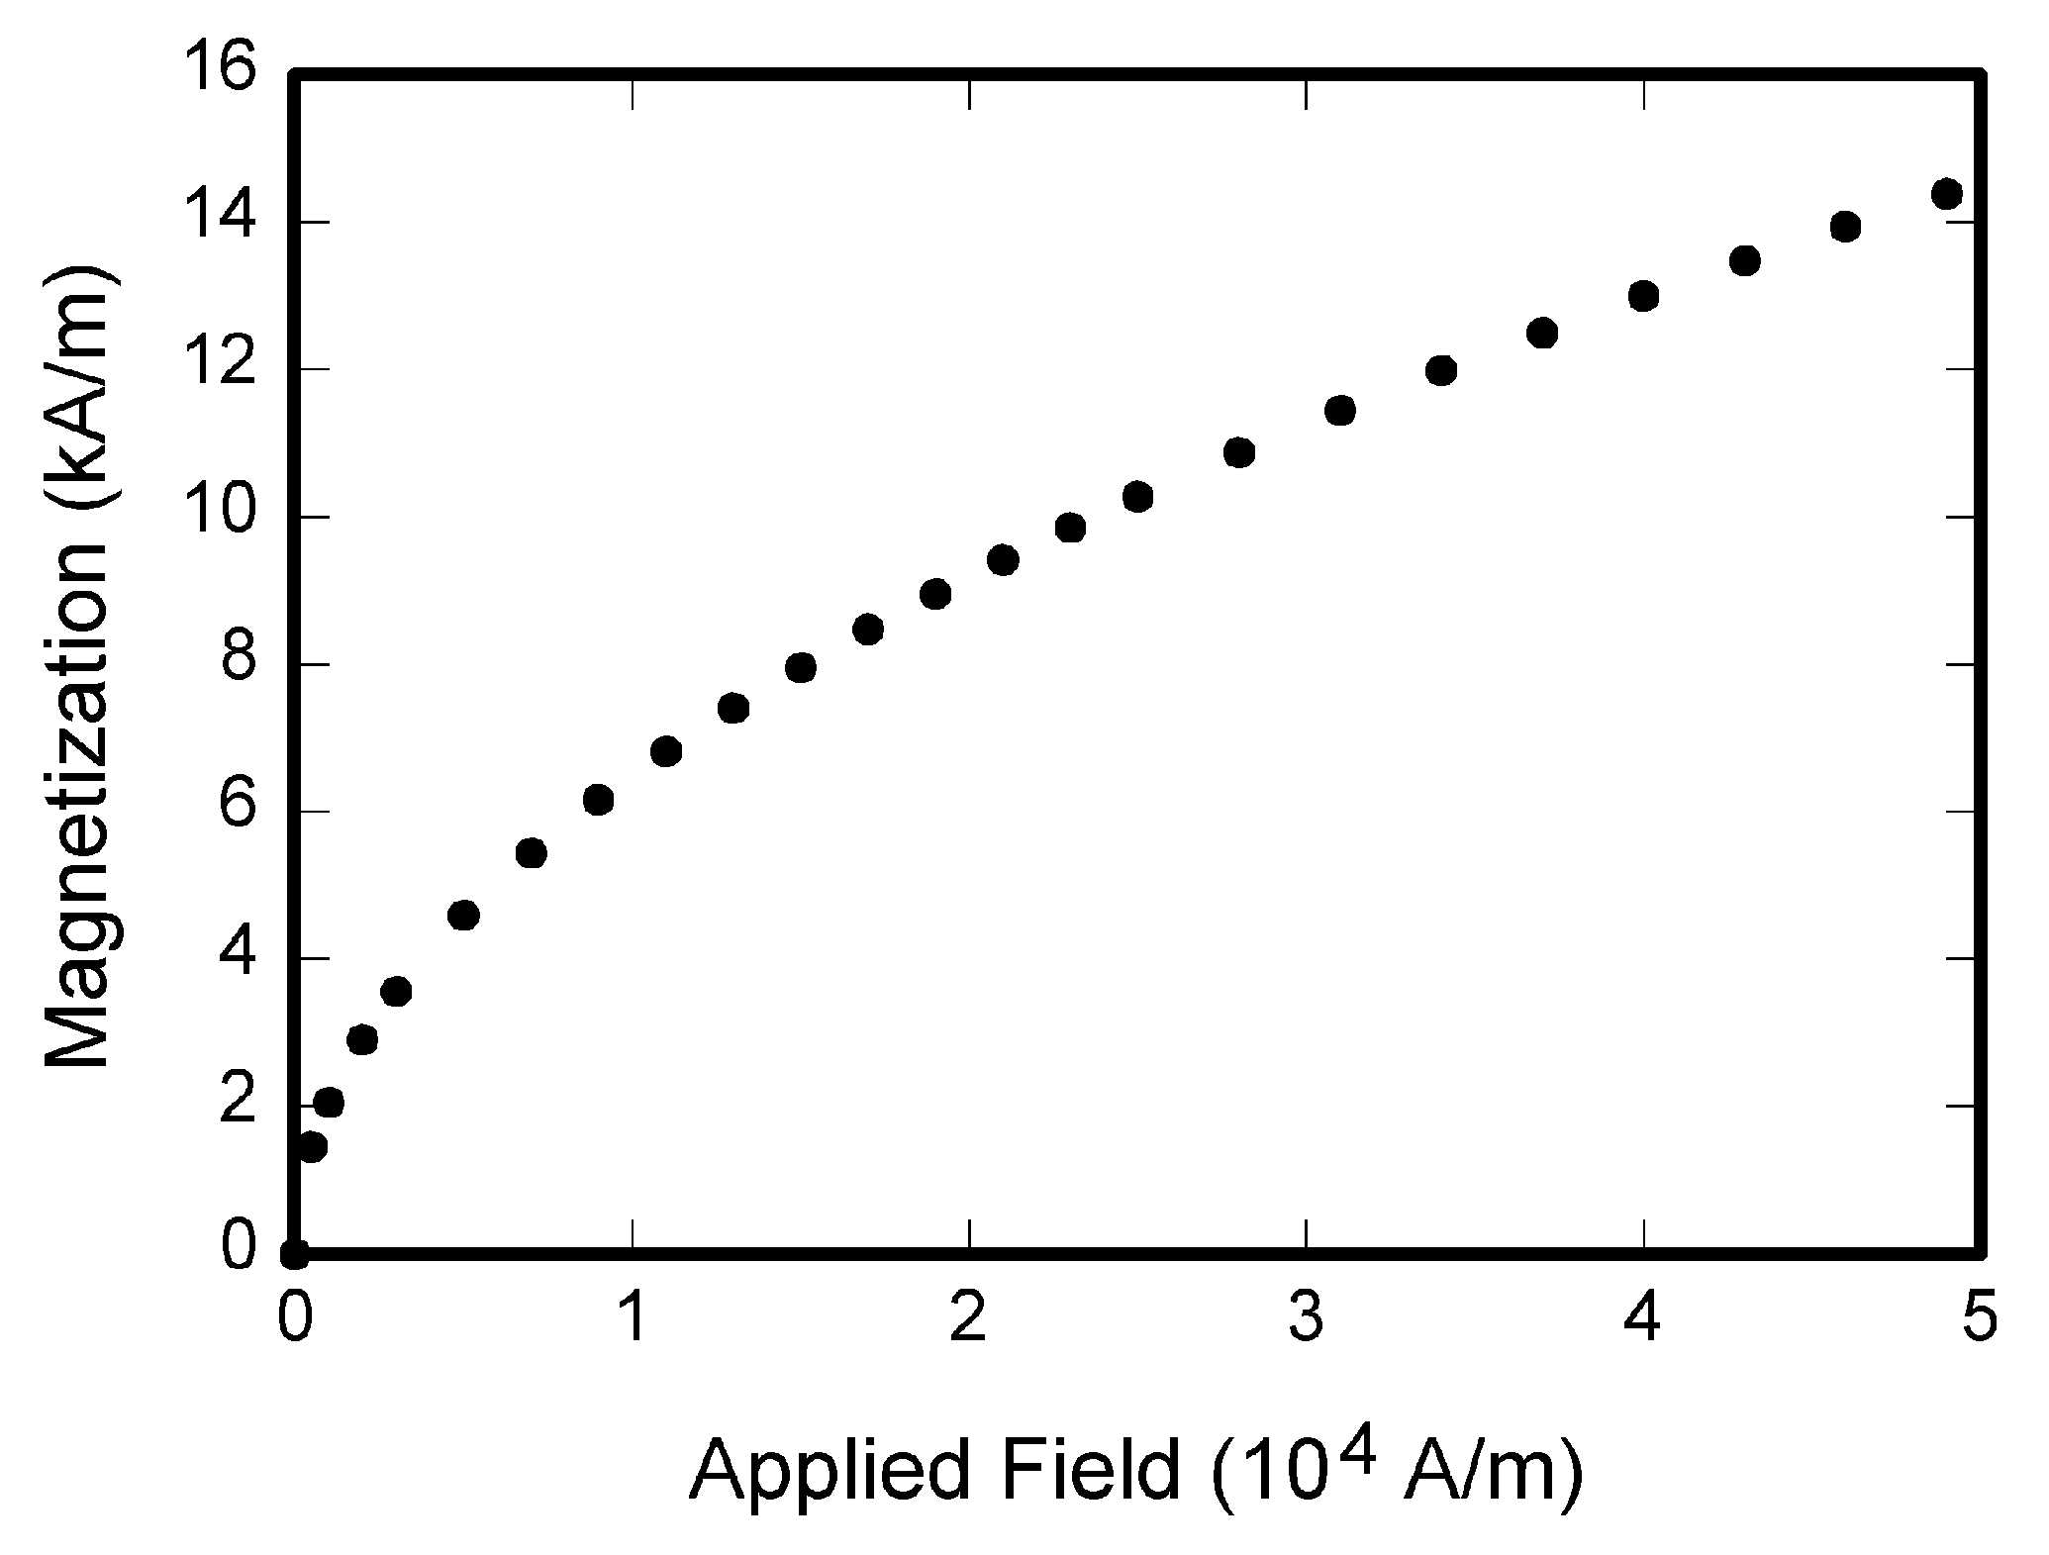

Fig. 1. Captions are centered in the column if they are shorter than the column width. Otherwise, they must be justified in the column. Use 9-point Times New Roman for the captions.

IV. Discussion

Use either SI (MKS) or CGS as primary units. (SI units are strongly encouraged.) English units may be used as secondary units (in parentheses). This applies to papers in data storage. For example, write “15 Gb/cm² (100 Gb/in²).” An exception is when English units are used as identifiers in trade, such as “3.5-inch disk drive.”
Avoid combining SI and CGS units, such as current in amperes and magnetic field in oersteds. This often leads to confusion because equations do not balance dimensionally. If you must use mixed units, clearly state the units for each quantity that you use in an equation.

V. Conclusion

Finally, you are responsible for language as editors will not check it. Do a spell and grammar check. This is available in Word. If English is not your native language, get a professional proof-reader to help if possible.
The word “data” is plural, not singular. The subscript for the permittivity of vacuum ε₀ is zero, not a lowercase letter “o.” In American English, periods and commas are within quotation marks, like “this period.” A parenthetical statement at the end of a sentence is punctuated outside of the closing parenthesis (like this). (A parenthetical sentence is punctuated within the parentheses.) A graph within a graph is an “inset,” not an “insert.” The word “alternatively” is preferred to the word “alternately” (unless you really mean something that alternates). Use the word “whereas” instead of “while” (unless you are referring to simultaneous events). Do not use the word “essentially” to mean “approximately” or “effectively.” Do not use the word “issue” as a euphemism for “problem.”
Be aware of the different meanings of the homophones “affect” (usually a verb) and “effect” (usually a noun), “complement” and “compliment,” “discreet” and “discrete,” “principal” (e.g., “principal investigator”) and “principle” (e.g., “principle of measurement”). Do not confuse “imply” and “infer.”
Prefixes such as “non,” “sub,” “micro,” “multi,” and “ultra” are not independent words; they should be joined to the words they modify, usually without a hyphen. There is no period after the “et” in the Latin abbreviation “et al.” (it is also italicized). The abbreviation “i.e.” means “that is,” and the abbreviation “e.g.” means “for example” (these abbreviations are not italicized).

Acknowledgment

The preferred spelling of the word “acknowledgment” in American English is without an “e” after the “g.” Use the singular heading even if you have many acknowledgments. Avoid expressions such as “One of us (J.Q.A.) would like to thank ....” Instead, write “J. Q. Author thanks ....”

References

- L. Onsager. Deviations from Ohm’s law in weak electrolytes, Journal of Chemical Physics, 2:599–615, 1934.
- A. Castellanos. Electrohydrodynamics. Springer-Verlag, 1998.
- J. E. Monzon, EHD of multi-phase flows, in Proceedings of the 3rd Conference on Complex Fluids, T. Taylor and G. Bachmann (ed.), 50–53, 2021.
- V. Medina, R. Valdes, J. Azpiroz, and E. Sacristan. Title of paper if known, unpublished.
- E. H. Smith. A note on particles and cells manipulation, Microfluidics and Nanofluidics, in press.

